目录

Chapter 5 1

What program data is shared 1

Race Condition 2

Critical Section: 2

Possible solution 3

Several failed example 3

Peterson’s Alg 5

Hardware Atomic solution 5

testAndSet(() 6

Swap() 6

Hardware with bounded waiting 7

High level OS sync method 7

Lock 7

JAVA 9

Semaphore 9

Classic problem 10

Monitor 12

Seme and moni’ problem && message passing 13

Chapter 7 14

A deadlock situation can arise if the following four conditions **hold simultaneously i**n a system: 14

Deadlock prevention 15

Safe vs. Unsafe States 16

Banker’s alogrithm 17

Deadlock Detection 17

Recovery from Deadlock 18

EXAM1 QUES 19

FCFS, SJF, RATE MONOTONIC Algorithms … 24

# Chapter 5

## What program data is shared

Threads

Local variables are not shared (private)

--on its own stack

Global variables and static objects are shared

--Stored in the static data segment, accessible by any threads

Dynamic objects and other heap objects are shared

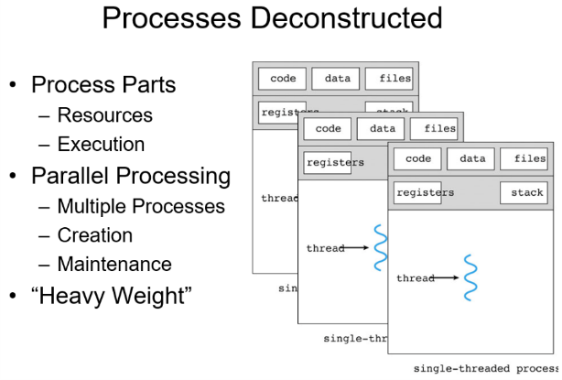--Allocated from heap with **malloc/free or** new/delete

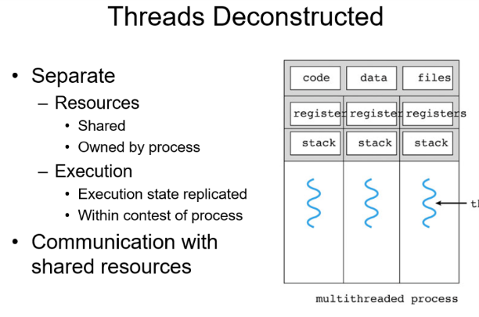

## Race Condition

Results depends on order of execution

## Critical Section:

--Part of program where shared resource is accessed

--Deadlock: 2 or more processes waiting on each other to finish before they can finish

--Starvation: One process waits indefinitely for the resources to complete its task, which are repeatedly allocated to other process

Required Properties: 1. Mutual exclusion 2. Progress (thread no in CS cannot block others from entering) 3. Bounded waiting(starvation free)

## Possible solution

Create atomic operations by disabling interrupts!

* Disadvantage

--Unwise to give processes power to turn of interrupts

Never turn interrupts on again!

* When to use?

--Good for kernel itself to disable interrupts for a few instructions while it is updating variables or lists

### Several failed example

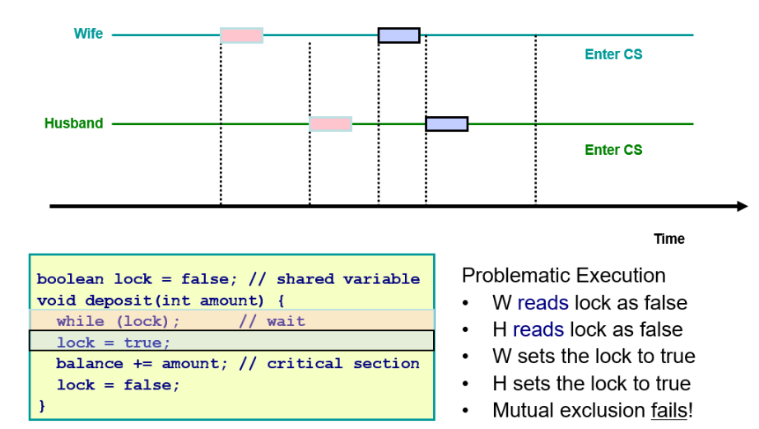

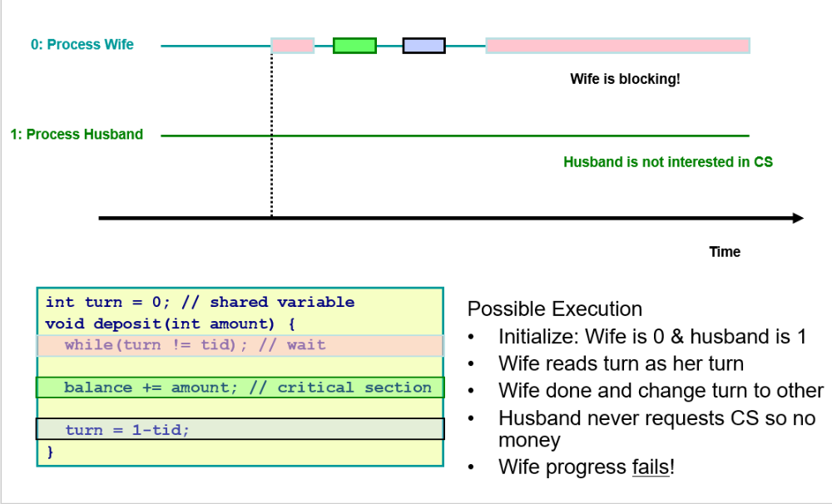

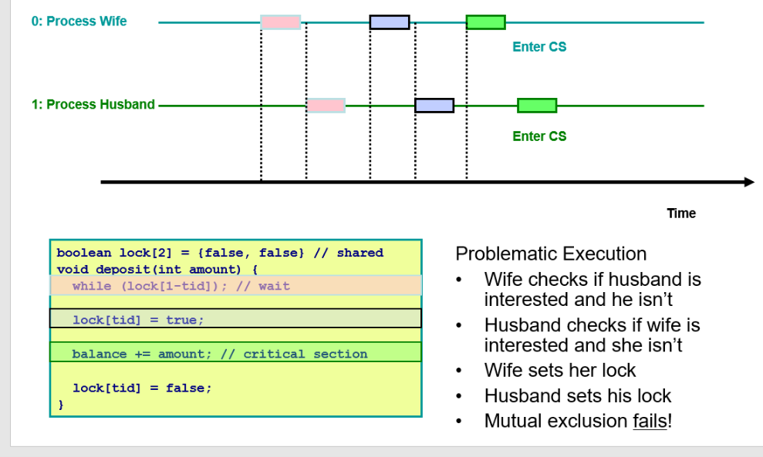

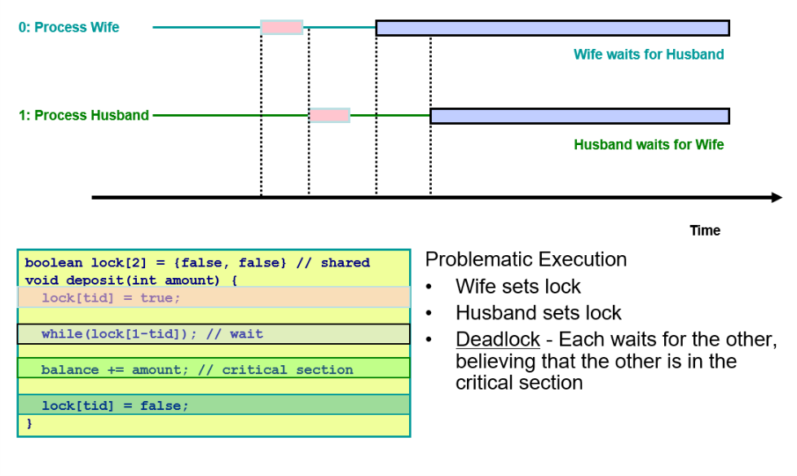

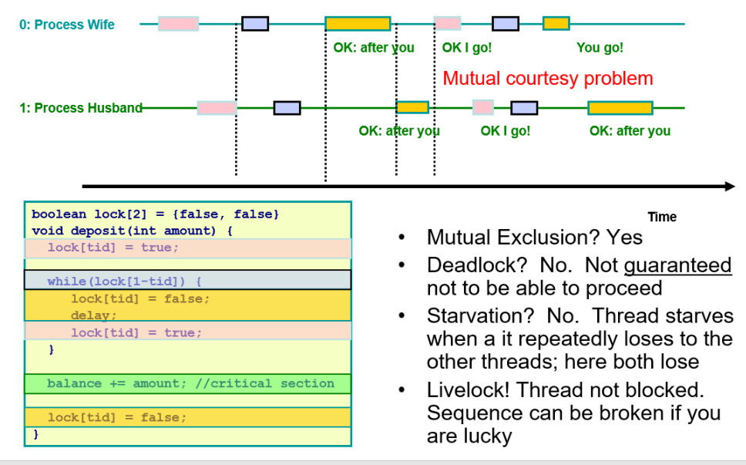

## Peterson’s Alg

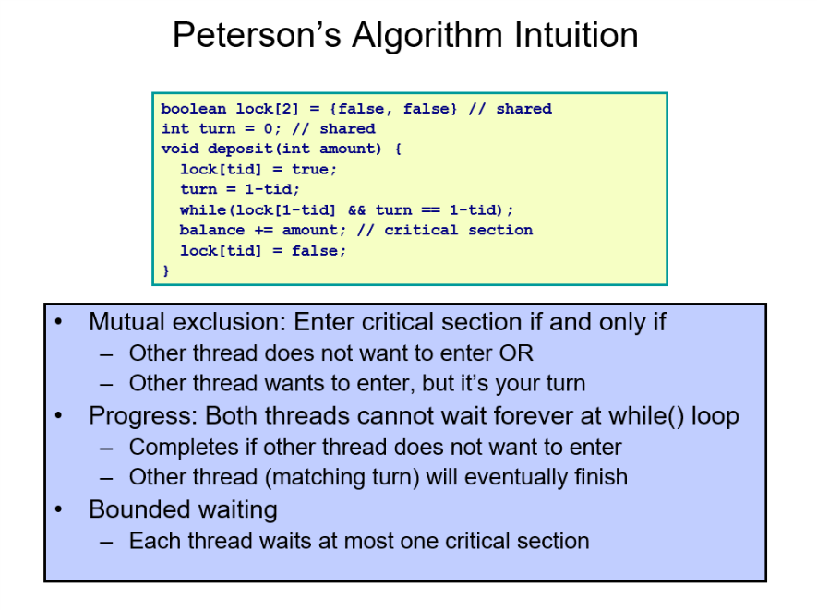

## Hardware Atomic solution

hardware instructions that provide atomic execution of tasks that normally take multiple instructions

### testAndSet(()

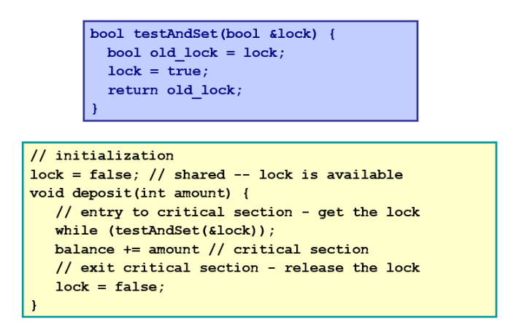

### Swap()

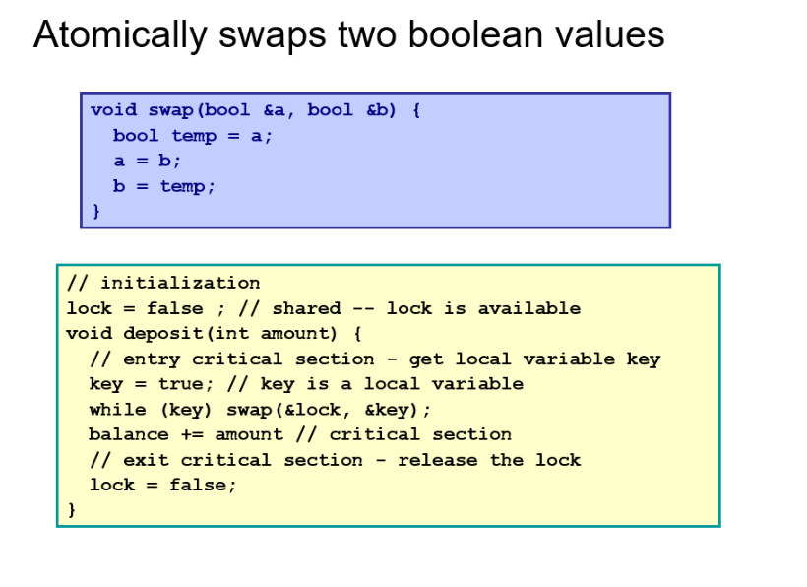

### Hardware with bounded waiting

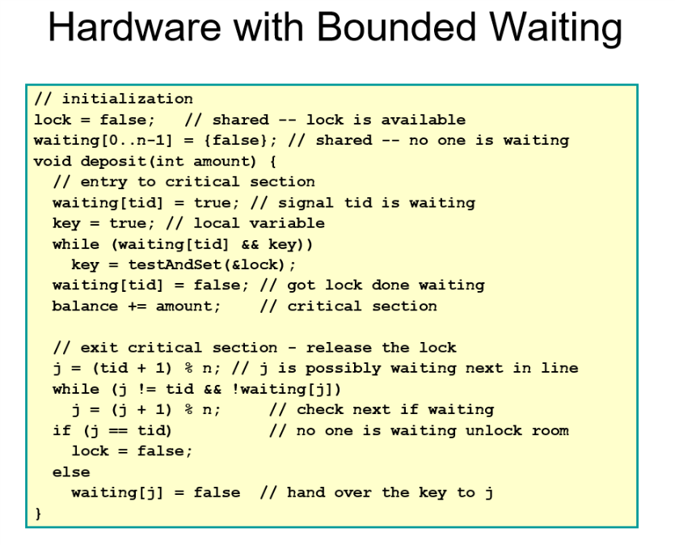



## High level OS sync method

### Lock

Acquire and release



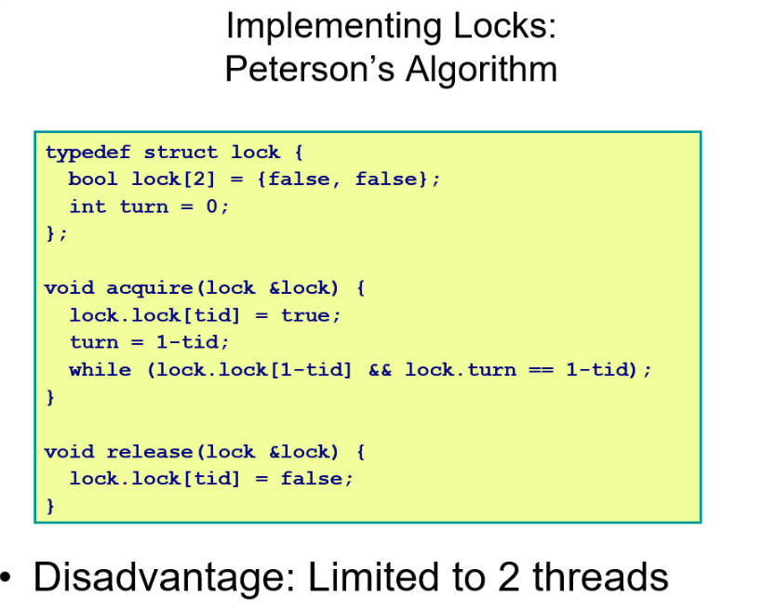



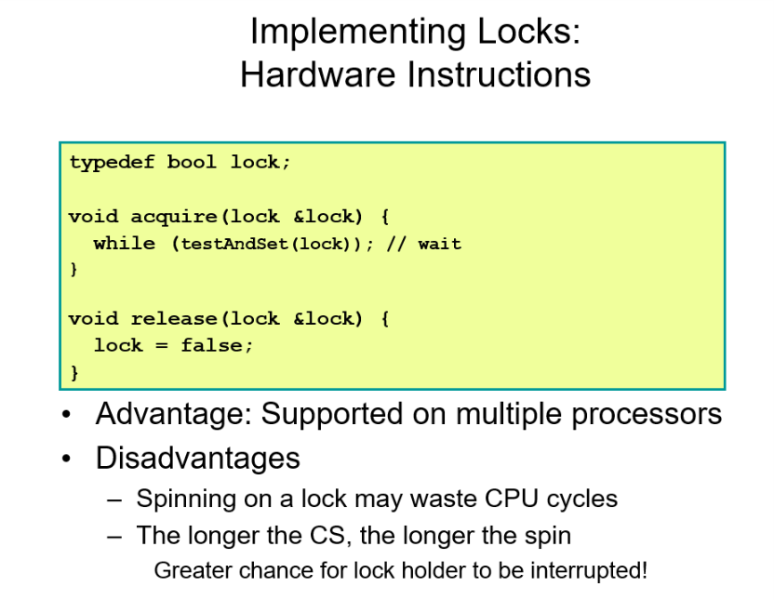



### JAVA

#### Synchronized

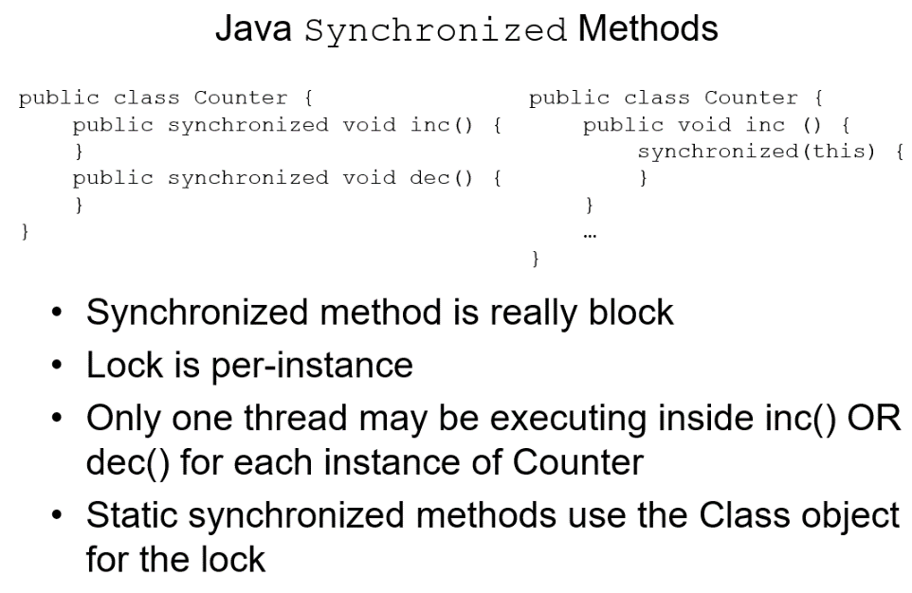



#### Volatile???

### Semaphore

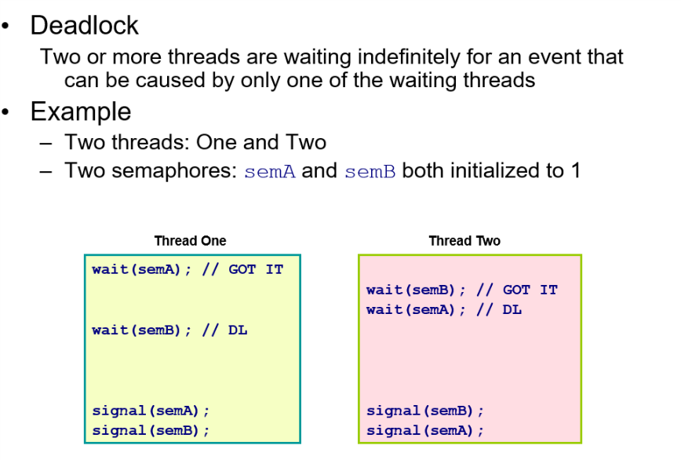

#### Pro and con

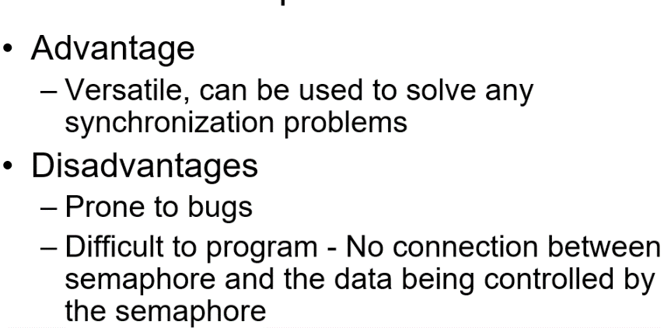

### Classic problem

#### Producer/Consumer

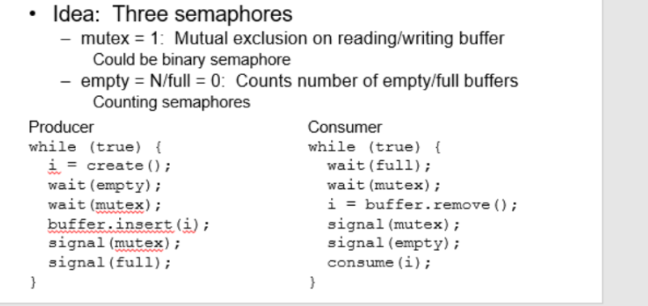

#### Reader writer

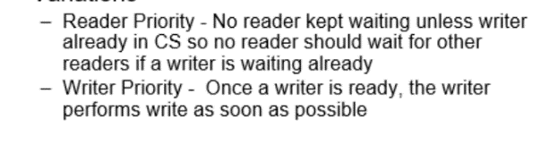

#### Dinning :

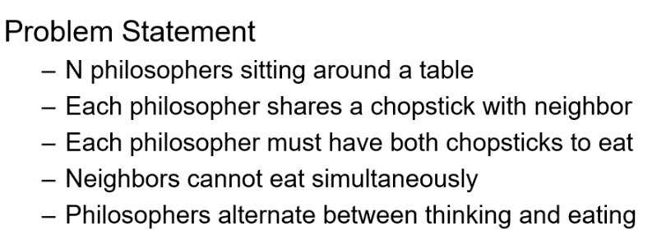

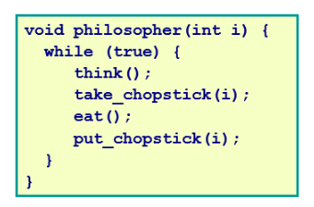

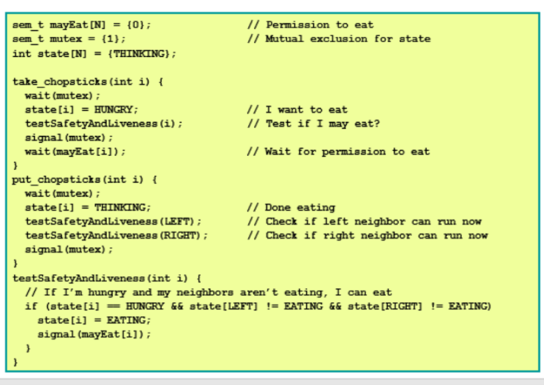

### Monitor

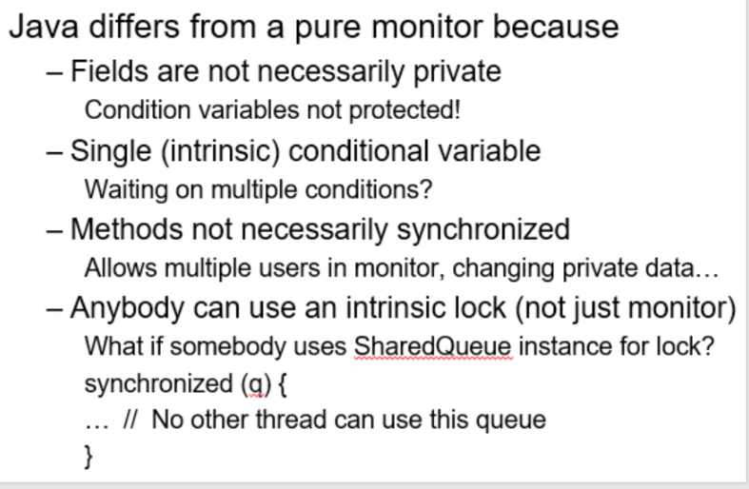

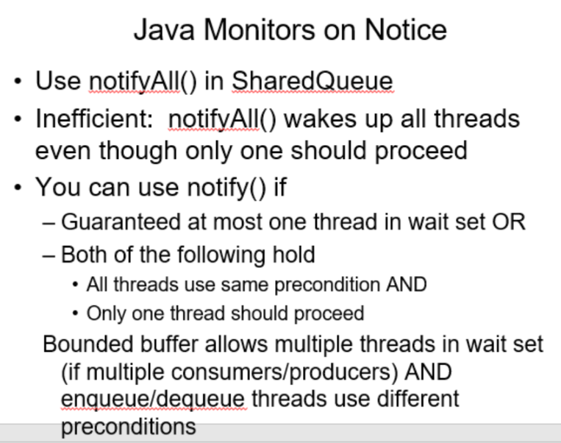

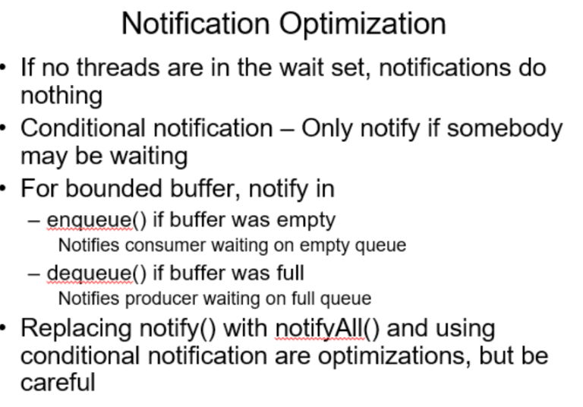

### Seme and moni’ problem && message passing

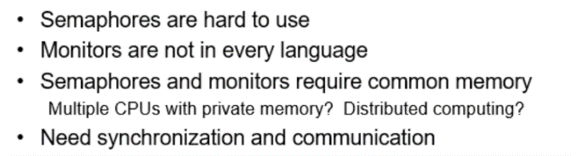

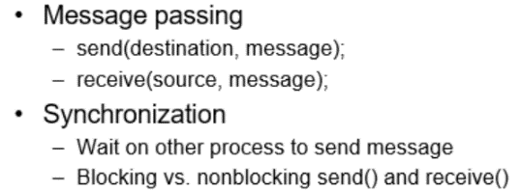

# Chapter 7

## A deadlock situation can arise if the following four conditions **hold simultaneously i**n a system:

1. Mutual exclusion – Only one process may use a resource at a time
2. Hold and wait – A process may hold allocated resources while awaiting assignment of others
3. No preemption – Previously granted resources may not be taken away
4. Circular wait – A chain of processes exists, such that each process holds at least one resource needed by the next process in the chain

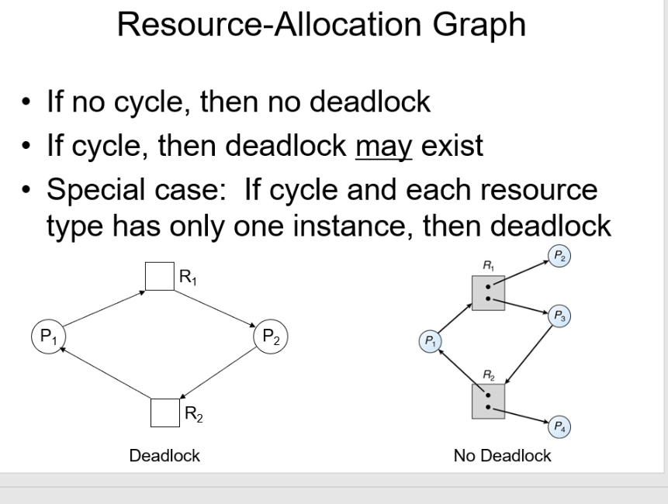

## Deadlock prevention

* + Avoid at least one of 4 necessary conditions for deadlock

Mutual exclusion, Hold & wait, No preemption, Circular wait

Deadlock Prevention

--eliminate Mutex

Make resource sharable, ex read-only files

Problem: some resources are nonsharable

-Eliminate Hold and Wait: Starvation??

--No Preemption:

* 1. Preempt requestor resource
  2. Preempt holder resource

Problem: Can’t take away a lock without causing problems

--Eliminate the possibility of a circular wait:

1.only one resource at a time

Very limited

2.impose global ordering for acquiring resources

Ex. Printer = 1, disk = 2, tape = 3 Processes must acquire resource in rank order

Problem: Inefficient (e.g., Need to read from tape to disk in order to print but must get printer first even if tape copy is long). No order satisfies everybody

## Safe vs. Unsafe States

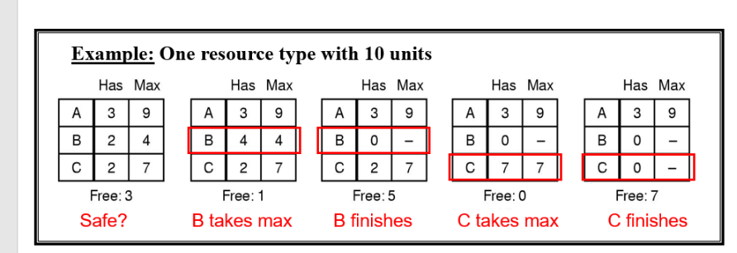A safe state avoids deadlock ( banker’s could find a way out, like in the first part)

An unsafe is not necessarily deadlocked but may lead to a deadlocked state (banker’s couldn’t find a way out, like in the second part)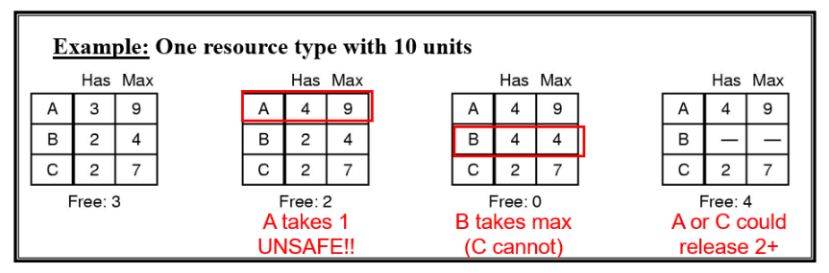

## Banker’s alogrithm

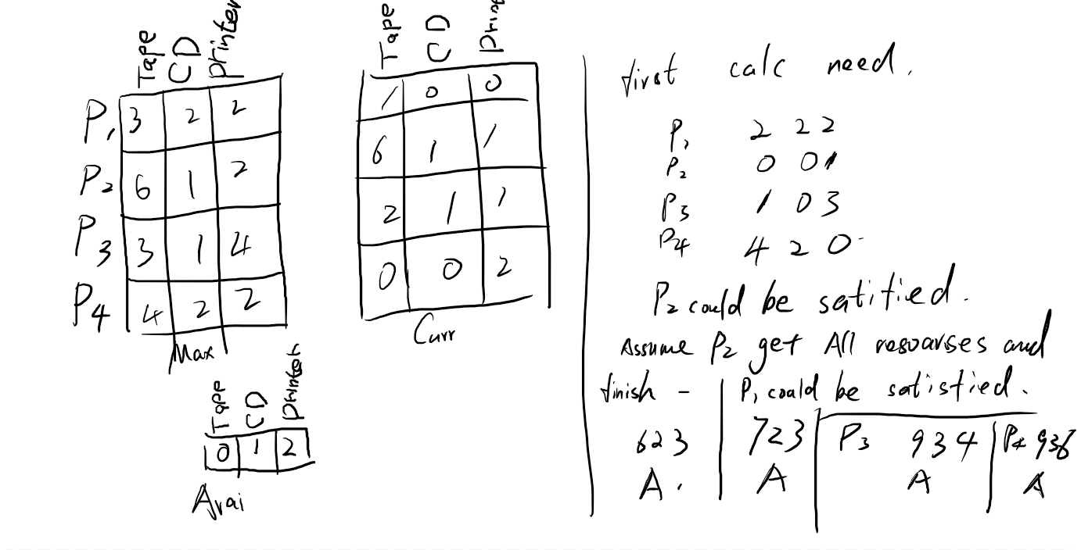

## Deadlock Detection

An algorithm to detect a cycle in a graph requires O(n2) operations???, where n is the number of vertices in the graph

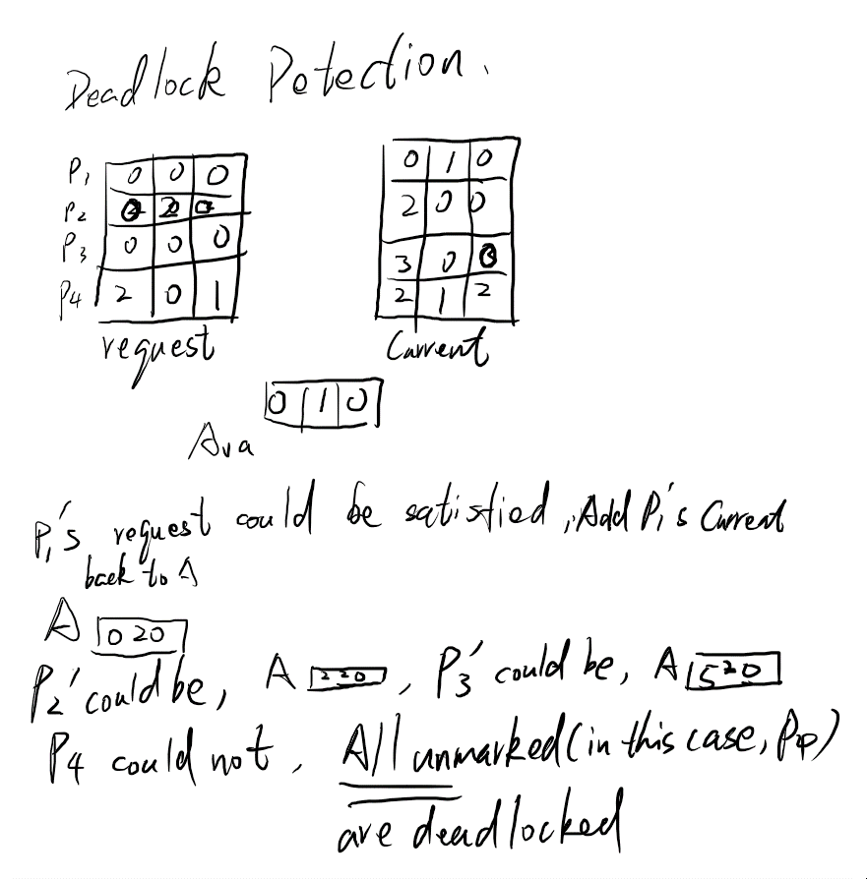

## Recovery from Deadlock

Process termination

Resource preemption

# EXAM1 QUES

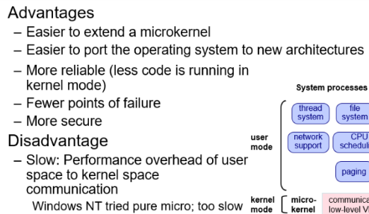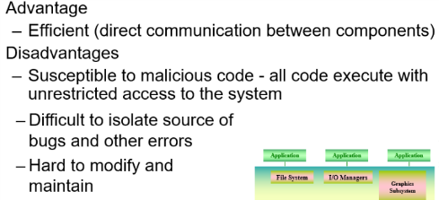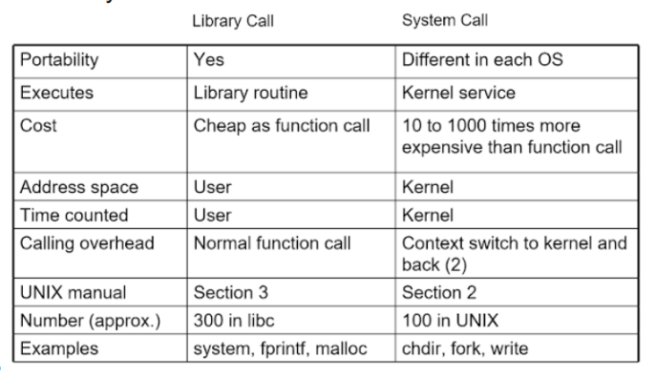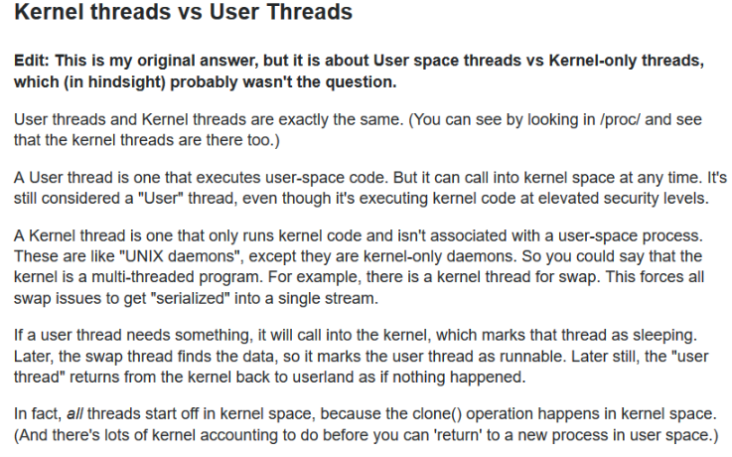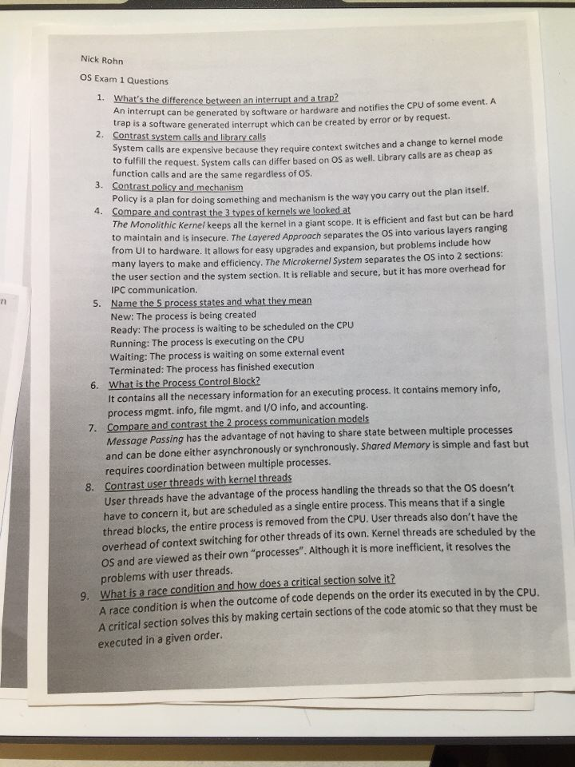



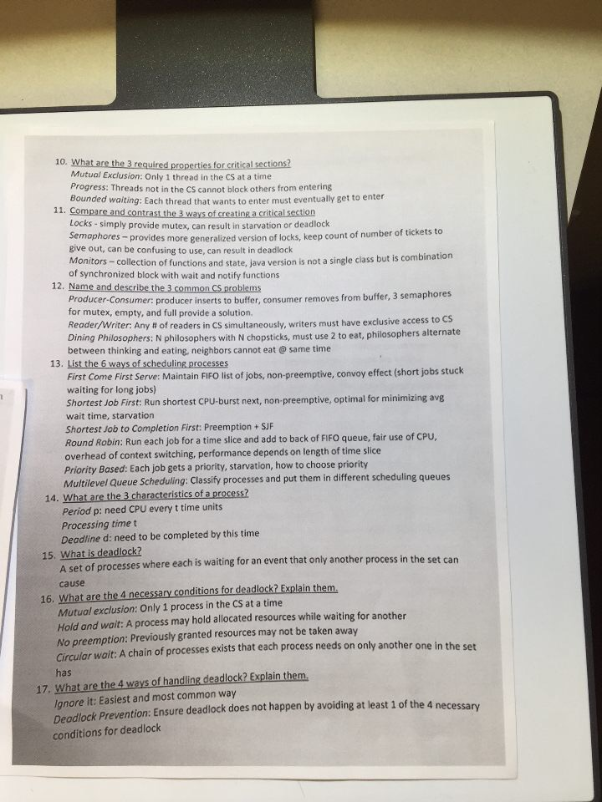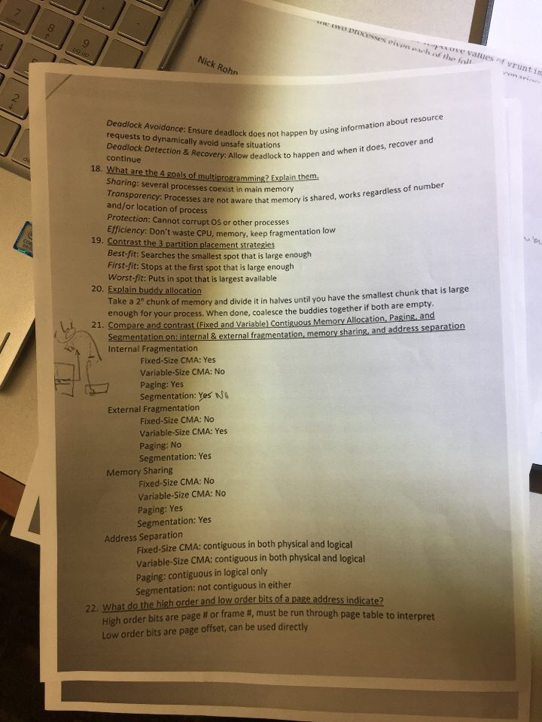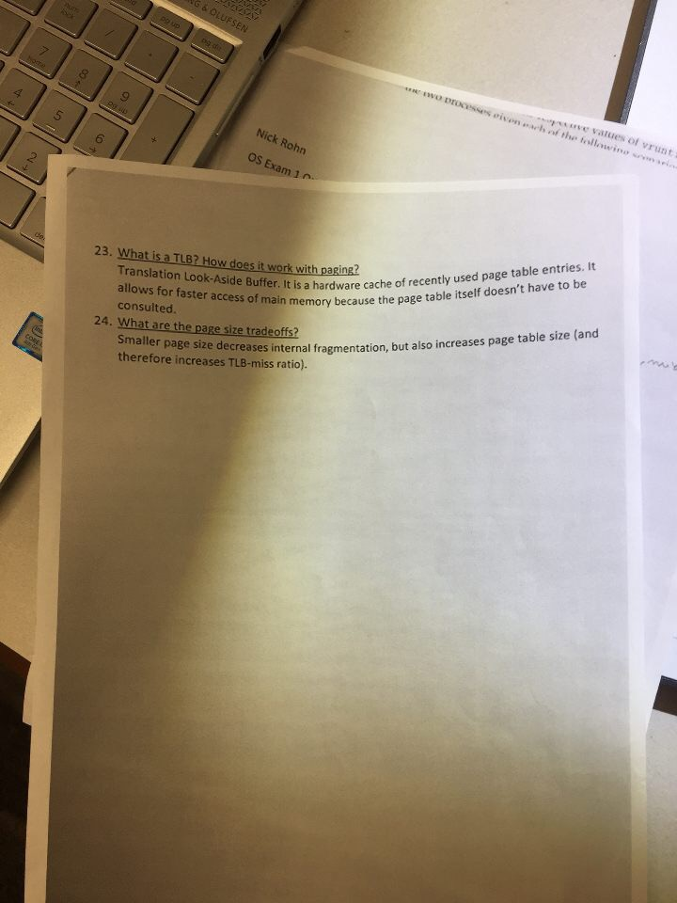



# FCFS, SJF, RATE MONOTONIC Algorithms …

**Turnaround time:**

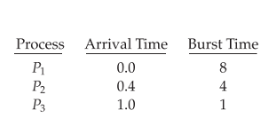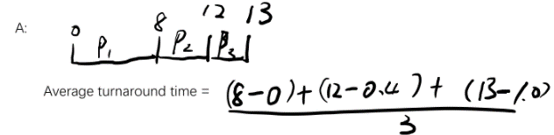

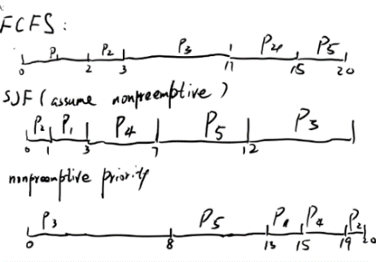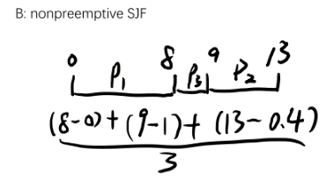

**Example2**

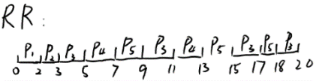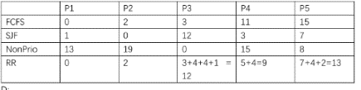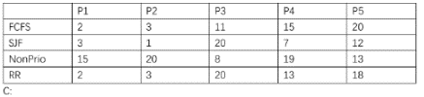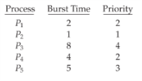 **turnaround time && waiting time**

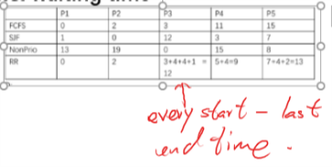 **Response time is time(first response) is time(arrive)**

**Rate Monotonic**

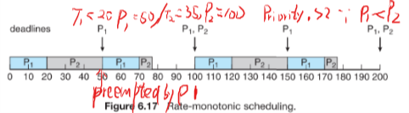

**earliest deadline first**

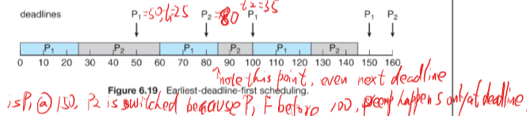

**When to use notifyall or notify (ppt 2 sentences)**

**Chapter 8 尤其重要,HW**

**以及exam2 doc过**

